Front Wheel Bearings in a 3000
About fifteen months ago my car passed its (annual) MOT. (UK road worthiness test). I’d thought that it would and all was well. The tester, a fairly “old-school” mechanic at our local garage, said that my front right hand wheel bearing was a little off….not worth a “notification”, certainly not a failure. The front bearings had been replaced, by me, in November 2005 and checked for grease etc on a regular basis so, as I could detect virtually no movement, I was not overly worried. He said the same thing this year! There was, maybe, a fraction more movement, but how can one judge the difference over 12 months? Anyhow, I determined to get in there and have a look. I bought an inner and outer bearing, races and an oil seal. I thought that I might as well replace the lot if I was going to strip it all down. Bearings are not expensive and can be bought from a local bearings distributor or off eBay. Anyhow, I got the car up onto the ramp, took the wheel off, started the strip down and eventually discovered the problem.

Now, my car is a MkII BT7 with wire wheels and disc brakes. But most of this article will apply to all Big Healeys and maybe the Sprites as well. Maybe not in mechanical terms, but the precautionary element is worth considering. Just for interest, my hub was stamped “Mowog” so is probably as old as the car. (Mo Wo G = Morris Wolseley (M)G)

Before you start, and let’s assume you’re doing both wheels, you’ll need: 2 inner and outer bearings, their races and 2 oil seals. As for shims, you should have at least one 0.020” or 0.025”, a couple of 0.010”, a couple of 0.005” and about three 0.003” shims per side. Most of our suppliers will just sell you a pack of them. (If you’ve bought new “washers” (4), you’ll probably need 2 packs. See below). Used shims can be reused.

I shall refer to parts as labelled in the BMC diagram, below.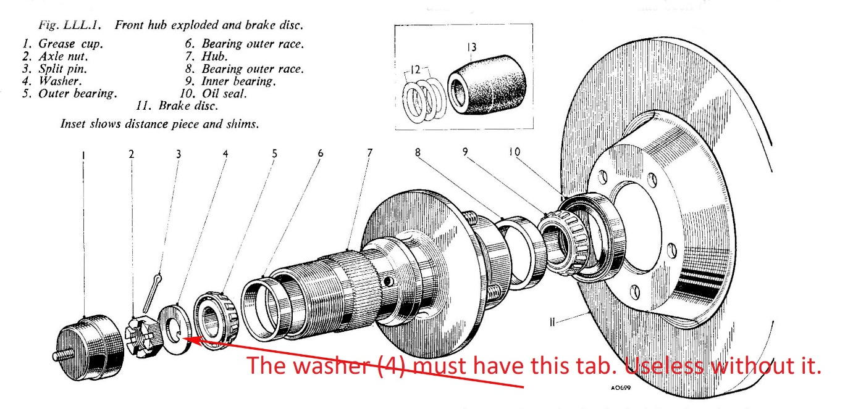
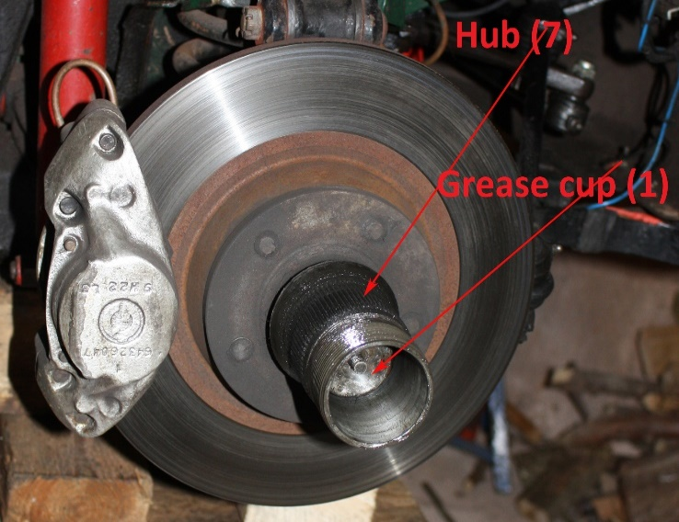
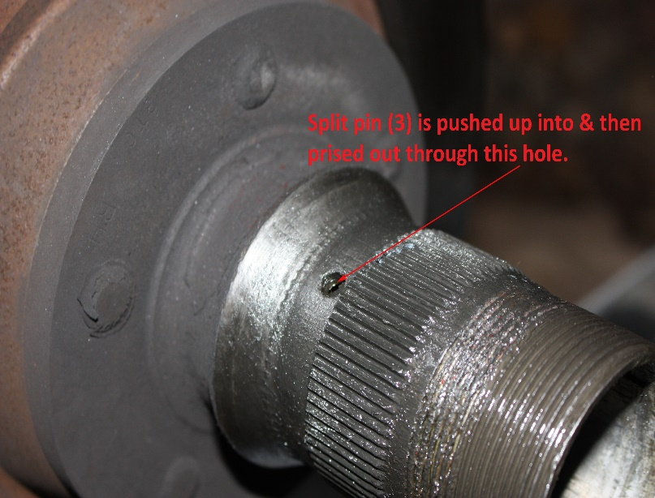
Once the wheel is off and the car is properly supported, you will be faced with something like this, on the left.

I refer you to the BMC manual for most of the procedure involved.
1) One does not really need the “extractor provided in the tool kit” for the extraction of the “Grease cup” (1). One can usually heave it out with something or other, but the tool costs very little and it’s a useful thing to have in your armoury.
2) A magnet on a stick tool is useful for this project. You’ll see why.
3) Don’t disconnect the calliper; leave it attached. Just hang it up somewhere out of the way. Much easier. Do try to insert something between the brake pads but you’ll need to hang up the calliper first and, by the time the knot is tied, the pistons will have very probably have moved the pads inwards.
4) Now, the split pin. Always a bundle of laughs. If you’re lucky, it’s not been turned over too far at its end ie where it emerges on the other side of the castle nut. Using a pair of long nose pliers, squeeze the ends together whilst angling the pin across the nut. At the same time, try to get something into the “eye” of the split pin. Once it has begun to move, it’s usually easy enough. Line it up with the hole in the hub, a bit more heaving and cursing and you should get enough out so that you can prise it out with an awl or similar.
5) Remove the nut with a six point 1⅛” socket. A more usual multi-point socket might do the job, but, as you crank up the ft/lbs, you’ll probably (a) wreck the (expensive) nut and (b) now be unable to get the nut off. Having that nut stuck down that greasy tunnel is not good news.
6) Remove the washer. Magnet. Check that the washer has its tab on the inside circumference. The washer is worse than useless without that tab. See below.
7) Unless you’ve had a major overheating issue, you will not need a hub extractor. Now, the manual advises one “not to attempt to remove the hub by pulling on the brake disc. The hub is withdrawn complete with the inner and outer bearing and oil seal”. Well, that rather implies that the hub will come off with all bearings, shims etcetc all tightly lined up inside. Well, it won’t; it can’t. Once the bearings etc are pulled off the swivel axle, everything separates inside the hub. And that’s fine. No problem. The “not to attempt to remove” advice means “don’t whack the back of the disc with a sledge hammer”. No….take the nut and washer out and rock the disc; the hub will loosen on the axle. The “Outer bearing” (5) should become loose inside and, as you pull the hub outwards, it will come out of its race and off the swivel axle. Now for the magnet! Then, if the hub won’t come all the way off, look inside and check that nothing is too far off centre and getting stuck. If it still won’t come off, pull harder…..the “Inner bearing” (9) may have been on the axle for 50 years.
8) Now clean off the hub, inside and out, with whatever you prefer. I used white spirit.
9) There is an implication in the manual that one can gently pry out the oil seal and coax out the races with a few kind words and a gentle tap or two. Personally, I’ve never got an oil seal out intact. In fact, I’m not sure I’ve ever tried. Buy new oil seals and expect that you’ll mangle the old ones. The two races will tap out (fairly brisk taps!), but you need to be careful to keep them straight. Tap on one side, then on the other etcetc. Now that the grease and crud of ages is out of the hub you will see the “cut-outs” that make the whole process so easy. Do not be tempted to leave the old races in situ….if your old bearings are worn, so are their races. Purists will use brass drifts at this stage……I don’t really see why. You are not going to be re-using the races and they are pretty tough anyhow; just be careful not to get over-excited and gouge the inside of the hub.
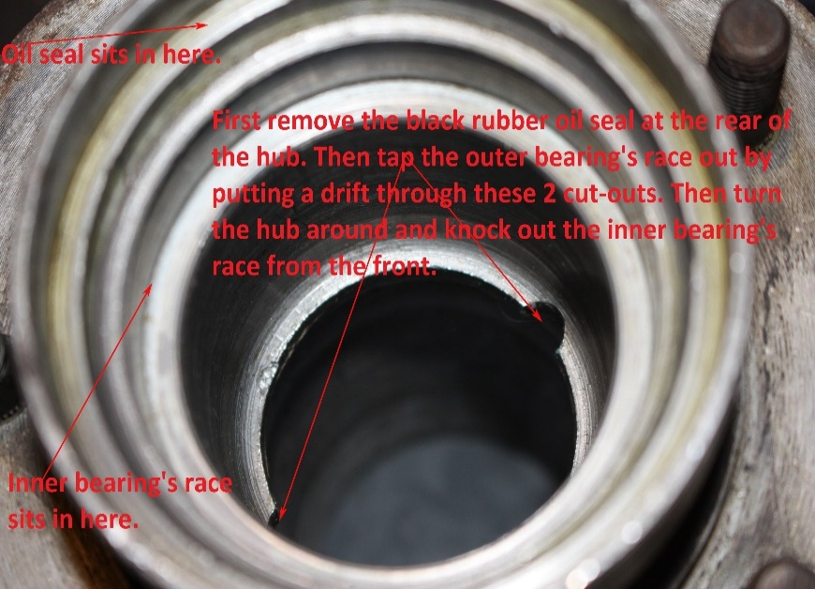
10) Now for the fun part. Read the manual and weep. All that stuff about “end-float”; enough to stop one dead in one’s tracks. Ignore it for the time being.
11) Put in the two new races. “Press” them in if you’ve got the right kit, but – since you haven’t – just tap them in gently…..a little on one side, a little on the other. Plenty of oil. You’ll get them 99% of the way but won’t be sure about the last 1%. Don’t worry. Don’t clout them too hard. You’ll get to the last 1% in a minute.
12) Put the hub into a big vice, well padded. Inner side upwards.
13) Drop in the distance piece. Greased or oily, inside and out. Tapered end first, per the first diagram, above.
14) Pack the inner bearing with the correct grease. It should say on the tin. One tin will last you a long time. Insert the bearing into the race.
15) Put the oil seal into the hub. It needs to sit on top and be banged down flat….if it goes down on one side first, you’ll have a job to get the opposite side to go in. It’s a really tight fit, per its design and function. Take a scrap of, say, old marine ply and cut out a bit about an inch bigger all round than the oil seal. Put that on the seal and tap it in by banging on the middle of the ply wood. When seated, it should sit flush with the metal rim. If it stands a trifle proud, leave it….that’ll be sorted out with the missing 1%.
16) Push the hub onto the swivel axle. It won’t sit straight at this stage as it’s only supported by the inner bearing.
17) Ignore the blandishments of the manual. Do not pack the outer bearing at this stage and forget about the shims.
18) Push the outer bearing into its race and onto the axle. The hub will sit straighter now.
19) Keep the hub sitting straight on the axle and push the washer onto the axle. The washer’s tab locates in a groove along the top of the axle’s tapered end. Shove it on all the way.
20) Put the nut onto the axle and do it up. Keep tightening the nut, bit by bit, whilst rocking the disc and rotating the hub. Stop when the hub locks solid. Now you’ve pressed the races in that last 1% and the oil seal is snug and flush with the inner rim.
21) The nut has to be tightened to within 40 -70 ft/lb. Some say 50 – 70. Anyhow it’s a big spread and what it really means is that the nut has to be done up tight while the hub is free to rotate. And there’s the contradiction. (An aside, if the process takes you to the lower end of adjustment, say 45ft/lb, don’t panic. The split pin is there to stop the nut undoing.)
22) So, loosen off the nut until the hub rotates freely and then take your torque wrench and begin to tighten the nut down. What you are looking for is:-
i] Free rotation.
ii] 40-70 ft/lb on the nut
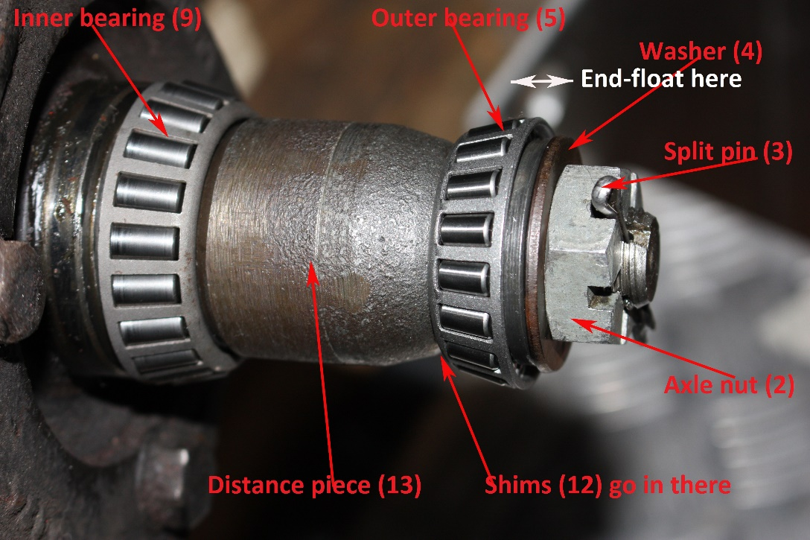
iii] Split pin lining up with the hole in hub and a slot in the nut whilst going through the hole in the swivel axle. Sort of like a camel and the eye of a needle. (There are two holes, horizontal and vertical, so don’t despair). See the photo, left. The bearings’ races are not shown as they just want to slide off and they get in the way anyhow. So, the photo shows what goes where and in what order.
23) Do look at the manual’s section on end-float. I don’t think you’ll be anything other than put off the process. No, consider what you have to achieve per 22), above, and go about it like this, remembering that the inner bearing is packed and the oil seal is tightly home:-
1. Sort shims from thickest to the thinnest.
2. Assemble without shims.
3. Tighten the hub bolt while spinning the hub, aiming to get between 40 & 70 ft/lb.
4. If the hub stops spinning you need shims.
5. Add a shim and repeat steps 4 and 5.
6. Once the addition of the thinnest shim will allow the hub to freely spin and its removal will cause the hub to have no play, you have the proper set-up.
7. Now see if you can tighten the nut up a fraction or back it off a fraction until the pin lines up, the hub rotates and you are still within 40 – 70. If you’ve achieved those, there absolutely shouldn’t be any wheel wobble at the hub. BUT, now’s the time to check.
8. Disassemble and pack the outer bearing in grease and reassemble.
9. Push in the grease cap; it must be pushed down all the way so that it’s over the nut and both ends of the split pin. Once that’s achieved, the split pin can’t misbehave. I pack the grease cup with grease per the manual. Some advise against this…..despite all the above, I don’t usually argue with the manual and if it says “pack it”, I pack it.
You will very probably have to repeat 4. to 7. several times until you get the correct combination.
Another aside:- When inserting the shims, note that there is a small step on the swivel axle and it is CRITICAL that you get the shims over this step and onto the shaft; otherwise, they get trapped, crushed and sheared in two. They can also get stuck which brings the whole process to a grinding halt. Personally, I put a thin smear of grease onto the shim and glue it onto the bearing and put bearing plus shim(s) onto the axle in one go. If the shims won’t come out during stages 4 – 7, you’ve got the magnet.

And now, almost finally, where did this all begin? How did I manage to wreck the outer bearing and leave the inner 100% intact? Well…..the tab on the inside circumference of my “Washer” (4) had broken off and was still in the groove that’s located on the top of the swivel axle. “So what?” I hear you all say. I quote a friend:- The washer’s role is “to give the axle nut a surface to bear on besides the inner race. Since the inner race is not supposed to rotate but has a clearance fit to the stub axle, the tab is there for insurance - to prevent the washer from rotating, and therefore additional incentive (friction) for the inner race not to rotate.” And another one:- “The purpose of the spacer is to provide bearing clearance but prevent the inner races and washers from rotating. Should the bearing be very dry - high friction - the risk is that, if they rotate and for long and fast enough, then they weld themselves to the axle. I have seen this with my own eyes and the damage caused when the repair mechanic removed the bearing with an oxyacetylene torch!!!!.” So, the tab matters….such a silly little thing. Moving on, but still on tabs, my old, probably original, washer was 0.093” thick. The new one is 0.09”. The difference is 0.003” which may not seem much but it’s actually a lot when you think of it in terms of shims??
(Another aside, there are two ways to get the holes to line up….…..as long as the torque setting is correct. One can add shims or one can take a little off the nut.). My tab was off, my washer was free to move (seemingly only a little) but the bearing was able to get loose and hot enough to begin to self-destruct without getting so hot that it went into melt-down, which all goes to show how well that grease does under extreme temperatures.

I don’t know about you, but I became frustrated by that part of the process that manifested itself as my doing everything right, but not really understanding precisely what was going on……where was this “end-float” and how did it work itself out? It seemed to me that managing “end-float” was just a fancy name for adjusting the clearance the bearings and the “distance piece” (13). Almost…it’s only actually the gap between the distance piece and the “outer bearing” (5). See the white double-ended arrow in the picture above. A friend of mine was similarly curious but he’s taken it to extremes! See below,:- 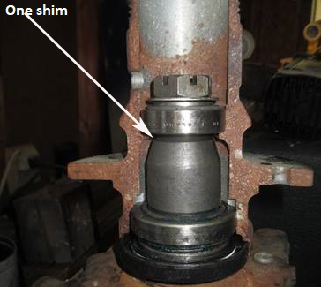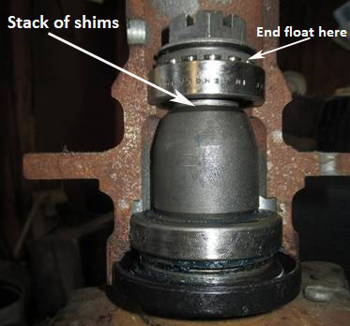
He’s chopped a hub in two and put in the various bits. On the left, there’s just one shim. On the right, there’s a lot of them and you can see how the rollers have been moved upwards or outwards thus taking the pinch effect off the rollers whilst still allowing the nut to be done up to the correct torque. (Thank you Steve Byers).
If you are still determined to have your bearings done by the local “expert”, make sure that he does use the shim and torque wrench method. I’ve heard of mechanics who point out that cars simply don’t need all these shims and distance pieces….look at their (vile) Subarus! Etcetc. Well, those things are machined to extremely fine tolerances. Ours were machined as cheaply as possible and the variations were designed to be taken up with shims As simple as that.

Front wheel bearings should be checked for wear every 5,000 miles and serviced (cleaned, replaced as necessary, greased, and repacked) every 25,000 miles. Now you’ve read all of this, you’ll be looking forward to it.

Here’s a hub extractor that I made earlier. Chances are that you’ll never need it!!

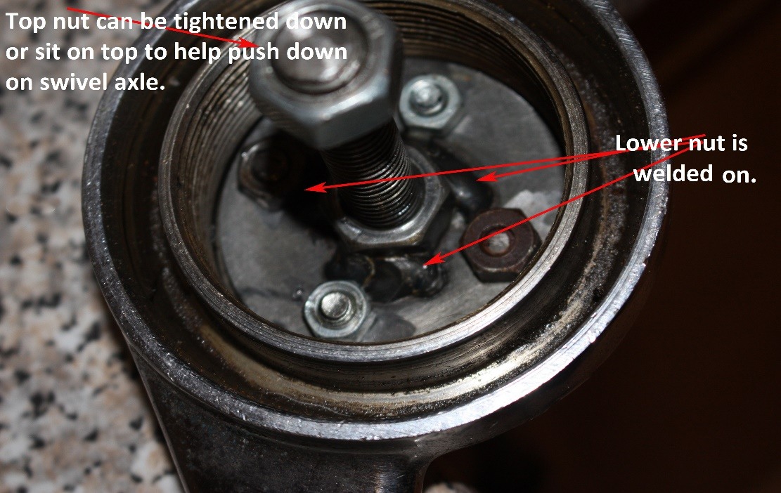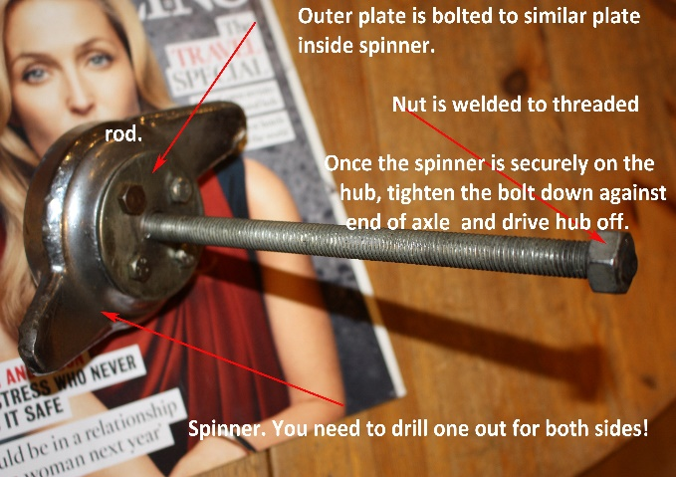
Simon Lachlan
February ‘18

